Guide 3. APT Project Final Report
Capstone Course

1. APT Project Final Report
The purpose of this report is to describe the most relevant aspects of your APT project. Explain the reasoning behind the decisions made throughout the process.

The following fields summarize the APT project and its main results. Complete them with the requested information.

Project name | Galactum — Real-Time World and Combat System — Team 3  Team members: Lucas Orellana, Mateo Orellana and Juan Castro. Computer Engineering, Duoc UC, Alameda campus. Project counterpart: Max. Version reviewed: MVP v0.12.
Professional practice areas | • Analysis and evaluation of IT solutions.  • Software development.  • Software quality and application deployment.
Competencies | • Develop a software solution using techniques that systematize development and maintenance and support achievement of the project objectives.  • Design and integrate components of a distributed interactive system using data models, network communication and separation of responsibilities.  • Apply version control, testing and reproducible deployment to verify an IT solution.

Final report contents
1. Relevance of the APT project | Problem and professional relevance  Galactum requires a shared space world in which ships and fleets can move, extract resources and interact with enemies. The challenge is to maintain consistency between the player's interface and the authoritative server state, particularly when resolving arrivals, extraction, damage and rewards.  For Computer Engineering, the project applies software architecture, communication protocols, state modeling, testing and deployment. Team 3 focuses on World and Combat within a larger project.  Context and affected users  This work is part of the capstone project provided to Duoc UC by its counterpart. Users include players and the teams integrating the world services. The instructor and evaluators need an executable workflow supported by traceable evidence.  Value provided by the prototype  The MVP supports entity selection, fleet composition, mining and xenoform hunting with visible results. Client-server separation places rule resolution on the server. Docker allows the demonstration to run in a browser. The verified scope is local and academic; production MMO capacity has not been demonstrated.
2. Objectives | General objective  Develop and integrate Galactum's World and Combat module, using an authoritative server and a Godot client to represent entities, manage fleets and resolve mining and combat interactions through a verifiable prototype.  Specific objectives  • Represent the solar system map and entities relevant to each client.  • Synchronize world state and decouple the interface from server logic.  • Implement fleet movement and resource extraction from asteroids.  • Resolve PvE encounters and record damage, casualties, wounded units and rewards.  • Prepare reproducible Docker deployment with persistent server storage.  • Verify behavior through manual and automated tests, distinguishing observed results from pending validations.
3. Methodology | Methodology used  The academic plan specifies an agile methodology based on Scrum. Implementation is organized into executable, reviewable milestones and increments:  • Scope definition: Team 3 World and Combat, keeping external systems and their contracts separate.  • Design: Godot client, authoritative server, JSON communication and balance catalogs.  • Incremental development: connection, replication, map, selection, marches, mining and combat.  • Verification: manual workflow with a test commander and screenshots; canonical and smoke suites available for documented execution.  • Management: technical game repository separate from the academic evidence repository. Published material must comply with the confidentiality agreement.  Suitability  Increments help locate component-level errors and demonstrate a working flow before integrating the next component. Docker reduces installation differences. Evidence links a player action to its visible result without replacing performance and concurrency tests that still need to run.
4. Development | Stages and activities  • Phase 1: project definition, responsibilities and organization of academic evidence.  • Technical foundation: Godot 4.6.2, GDScript and a WebSocket link using JSON messages.  • World: entities, asteroids, xenoforms and area-of-interest queries.  • Fleets and mining: selection of a level 1 copper asteroid and deployment of a 38-unit fleet; its march and resource return were observed.  • Combat: hunt against a level 2 Mist Weaver using 50 drones and 34 pilots. A report confirmed the defeated target and 4,200 damage.  • Data: JSON catalogs and server state saved in a JSON file. The MVP does not use an SQL engine.  • Interface: ship view, map, fleet composition and reports. The English/Spanish selector was verified, with some translations still incomplete.  • Deployment: Godot server and web client images, Nginx WebSocket proxy and saved-game volume. Supplied Docker output confirms the build and server health.  Enabling factors  The plan distinguishes Lucas's and Mateo's technical tasks; Juan Castro is also a team member. Decoupled components, separate balance data and an integrated runnable MVP support the work and the collection of real evidence.  Difficulties  • Time consistency: arrivals and resolutions require the server to retain authority over state.  • Environments: web export and the Linux server must use compatible Godot and export template versions.  • Pending coverage: suite output, two simultaneous clients and saved-game recovery remain to be documented.  • Partial translation: English labels were observed within the Spanish interface.  • Confidentiality: the academic repository must contain permitted evidence without exposing restricted code or material.  Adjustments made  • Docker Compose was added to build and run the demonstration without installing Godot on the host.  • In web mode, Play connects through /ws to the same origin served by Nginx.  • The MVP's JSON saving mechanism was retained and a volume mounted, without adding an artificial SQL database.  • Integrated MVP functionality, Team 3 responsibilities and pending validations were distinguished.  The evidence confirms a local playable workflow. It does not demonstrate production availability, robust authentication, MMO scalability, complete balance or failure recovery. Those validations require specific tests.
5. Evidence | Attached evidence supports the development stages and the resulting prototype:  • Reviewed technical references: world.gd, spatial_hash.gd, fleets.gd, combat_resolver.gd, client modules and gateway. This report describes their purpose without attaching source code.  • Real screenshots of the start screen, ship, map, mining, PvE preparation and combat report.  Ship of the test commander evidencia  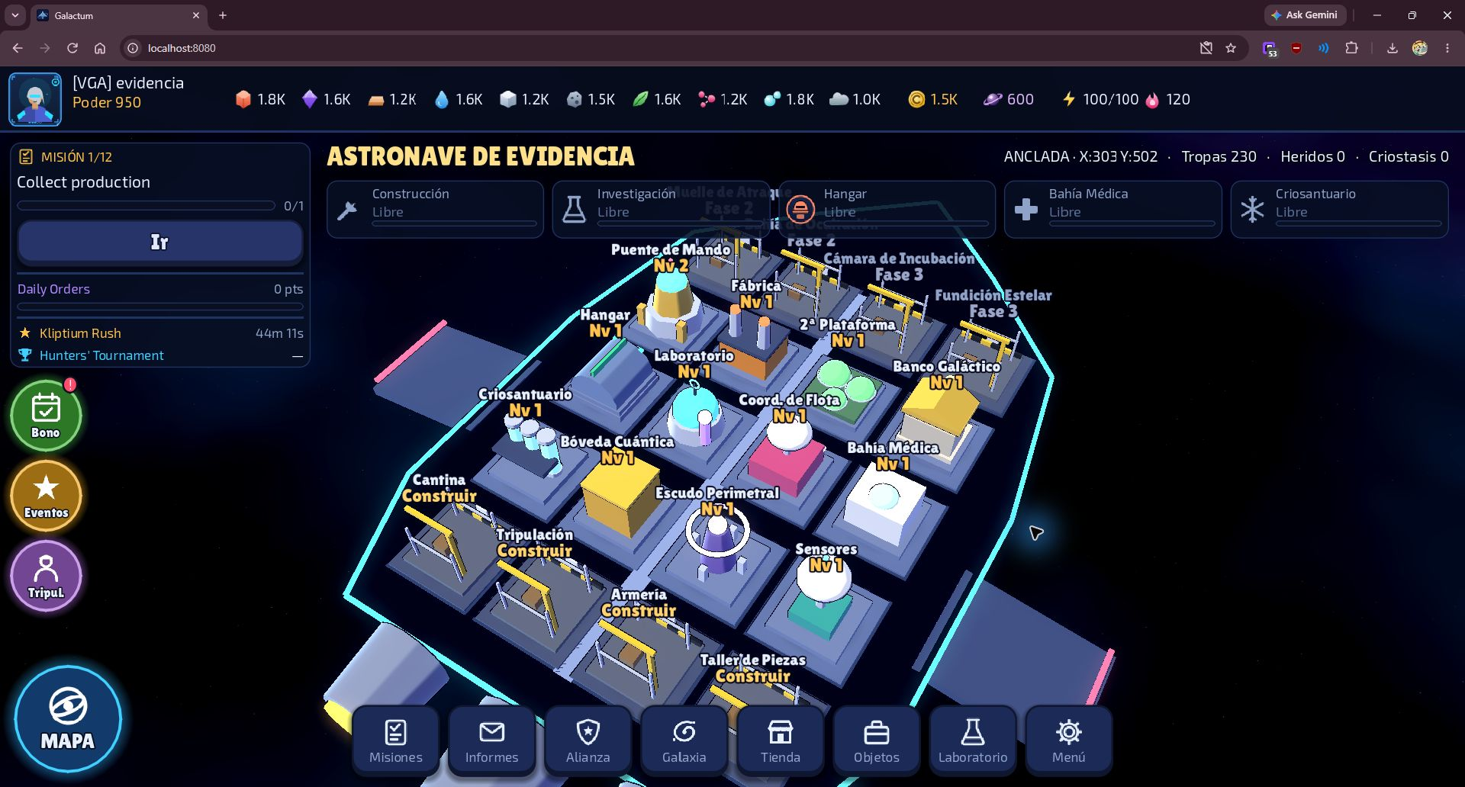  Level 2 xenoform hunt result  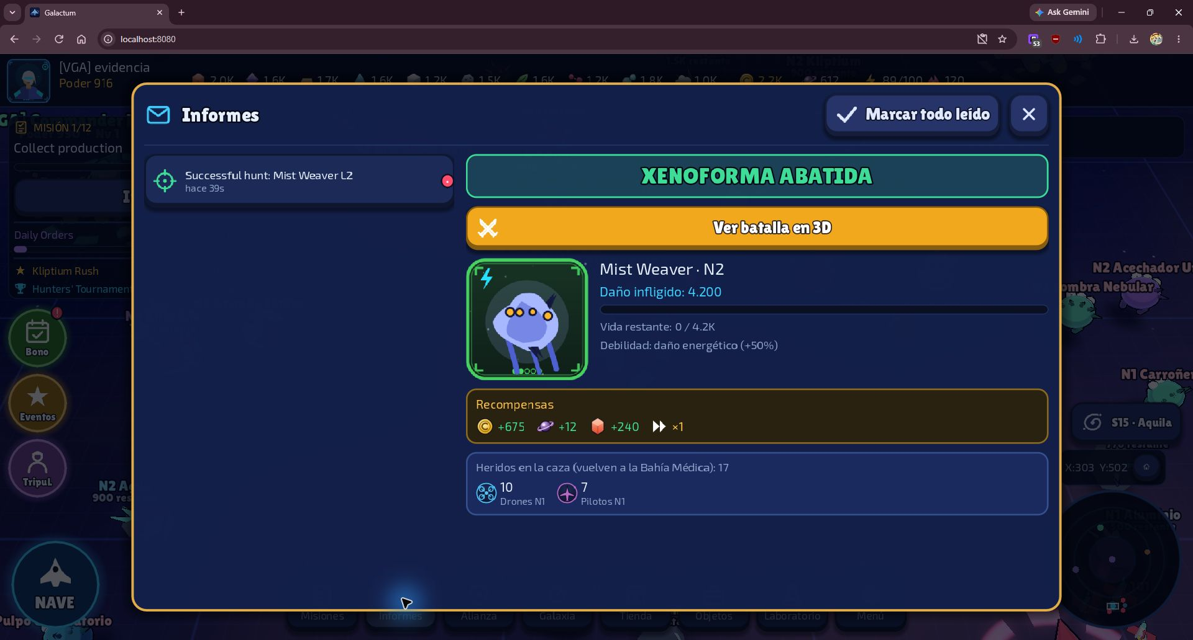  • Docker configuration and execution guide, with supplied records of both image builds and volume creation.  • Canonical suite, smoke test and balance harness available; their execution results still need to be incorporated into this submission.  • Phase 1 and Phase 2 academic documents and individual journals published according to the repository inventory.  • The presentation will be prepared after reviewing these documents; it is not attached as completed evidence.
6. Professional interests and future development | Contribution to professional interests  The work connects programming, client-server architecture and reproducible deployment. For Lucas, planned participation in environment setup, travel, mining and balance relates to an interest in infrastructure and operations. Mateo's planned tasks include spatial indexing, snapshots, spawning and profiling. Juan's specific assignments must be validated with the team before attributing modules to him.  Professional outlook  As a team, the goal is to deepen knowledge of distributed interactive systems, testing and operations. Next steps include performance measurement, concurrency and persistence verification, mobile testing and integration that preserves boundaries between teams.

